
AMERICAN INTERNATIONAL UNIVERSITY-BANGLADESH (AIUB)
Department of CSE Computer Aided Design and Drafting

Section: L Experiment No: # 03
Name: Khan, Md. Sazzad Id: 22–49172-3
Supervised by: MD. RAKIBUL ISLAM CHOWDHURY
Name of Experiment: Familiarization with different orthographic projections and drawing using AutoCAD software

AutoCAD Comments:

- How To Input Dotted Line In AutoCAD :
Type linetype >> Enter >> Click Load >> Select Desired Line >> ok
>> ok

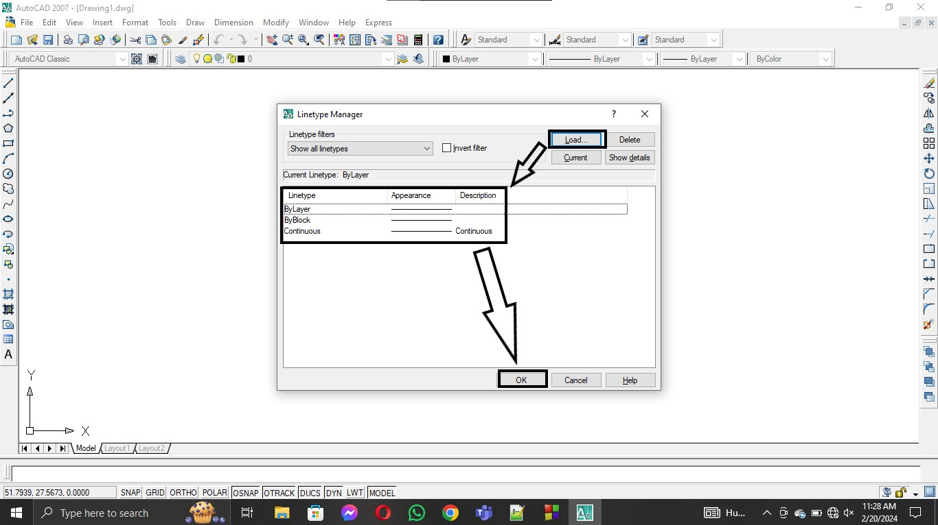

How To Plot A Drawing In AutoCAD :
Select File >> Plot >> Name : Select One >> Page size : A4 >> What to plot: Window >> Click Center The Plot >> ok
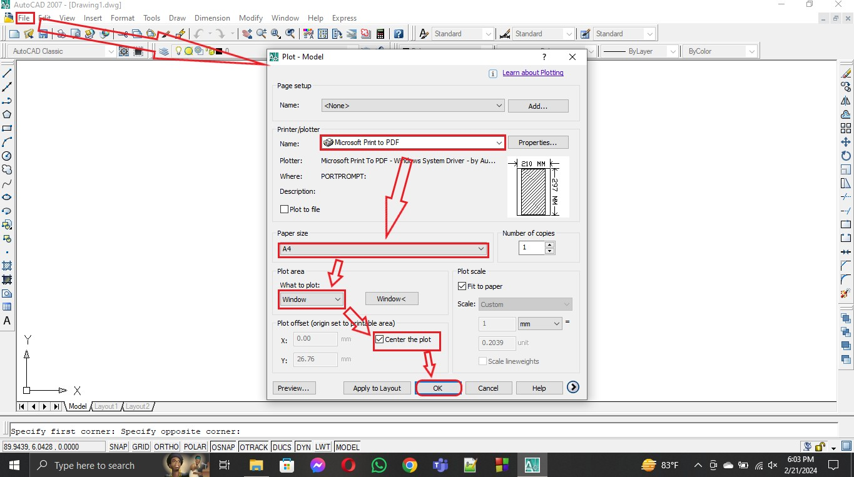

How To Write Text In AutoCAD :
Type mtext >> Enter >> Click on Starting point >> Click another Point >> Write >> ok

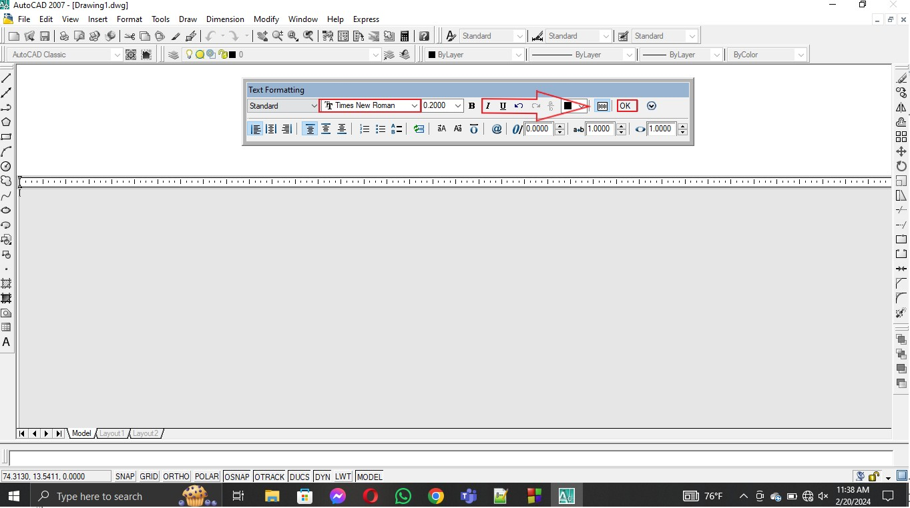

How To Move In AutoCAD :
Type Co >> Enter >> Select Objects >> Enter >> Click on base point >> put the crosshair in the side which you want to move >> input move distance or Click at a random point >> Enter

How To Copy In AutoCAD :
Type Co >> Enter >> Select Objects >> Enter >> Click on base point >> put the crosshair in the side which you want to copy >> input copy distance >> Enter

Exp - 3.1 Full Id is 22-49172-3 and id will be 72
3'-3.0"

6'-2.0"

Top View

Left View
6'-4.0"

Front View

3'-2.0"

6'-2.0"

Right View

Exp - 3.2 Full Id is 22-49172-3 and id will be 72

26'
78'
52'

Top View 26' 26' 26'

52'

Left Side View
52'
26'
26'
52'

Front View
26'

Right Side View

Exp - 3.3 Full Id is 22-49172-3 and id will be 72
3'-3.0"3'-3.0"

1'-7.5"

4'-10.5"

Top View

Left Side View
4'-10.5"

1'-7.5"

Front View

1'-7.5"
1'-7.5"

Right Side View

Exp - 3.4 Full Id is 22-49172-3 and id will be 72

6'-10.0"

6'-6.0"

Left Side View

Top View

5'-5.6"

Front View

2'-2.0"
2'-2.0"

2'-2.0"

2'-2.0"

3'-0.9"

2'-2.0"

Right Side View

Exp - 3.5 Full Id is 22-49172-3 and Id will be 72
2'-2.0"
2'-2.0"
1'-6.0"

5'-3.0"

1'-9.0"
1'-9.0"

Left Side View

3'-6.5"

2'-10.0
Top View

Front View
2'-1.5"
"
1'-9.0"

Right Side View
1'-6.0"

6'-4.5"

Exp - 3.6 Full Id is 22-49172-3 and Id will be 72
54'-4.2" 24'-1.8"
28'-6.0"

19'

Top View
28'-6.0"

16'-11.3"

39'-6.2"

29'

19'
28'-6.0"

16'-11.3"

45'-1.9"

Left Side View
Front View
Right Side View

